AI POWERED

HEALTHCARE CHATBOT SYSTEM

Rachakonda Hrithik Sagar Tuiba Ashraf

CSE C (specialized in AI and ML) CSE C(specialized in AI and ML)

Sharda University Sharda University

Greater Noida, Utter Pradesh Greater Noida, Utter Pradesh

Hrithiksagar36@gmail. Tuiba.ashraf107@gmail.com

Aastha Sharma L. Krishna Sai Raj Goud

CSE C(specialized in AI and ML) CSE F(specialized in AI and ML)

Sharda University Sharda University

Greater Noida, Utter Pradesh Greater Noida, Utter Pradesh

2018005582.aastha@ug.sharda.ac.in l.krishnasai1305@gmail.com

**INDEX**

Topics Page numbers

Introduction……………………………………. 3

History of chatbot……………………………… 4

Processing of Chatbot………………………….. 7

Ease of Use…………………………………….. 8

Some common mistakes……………………….. 9

Building the Bot…………………………….….11

Tabular design of disease record……………….13

Using Dialogflow………...……………….…....12

Decision Tree sample of our chatbot……….…..13

Developing the chatbot…………………….…...15

Normalizing the tech……………………….…...15

Making surety of chatbot……………………….16

Managing chatbot………………………………17

Coping when things go wrong………………….18

Understanding how successful the chatbot is…..19

Future-proofing of chatbot……………………...20

Word order similarity among sentence’s……….23

Future Improvements…………………………...21

Conclusion……………………………………...22

References………………………………………22

**Introduction**

Chatbots are the software applications that use Artificial intelligence and Natural Language Processing which is used to understand what a human wants in the particular field and guides them to get the desired outcome which also uses existing user conversations to provide better outputs in future. Chatbots are generally used a lot in customer interaction, marketing on social network sites and instant messaging the client.

Chatbots provide accurate and efficient information’s based on the user’s requirement.

Chatbots are used in dialog system for various purposes including customer service, request routing, or for information gathering. While some chatbot applications use extensive word-classification processes, NLP, and sophisticated [AI,](https://en.wikipedia.org/wiki/Artificial_intelligence) others simply scan for general keywords and generate responses using common phrases obtained from an associated library of database.

The technology of chatbots is, those are computer programs which simulate human conversations through voice commands or text chats sometimes both. Chatbots sometimes in short chatterbot is an Artificial Intelligence feature that can be embedded and used through any major messaging applications such as Facebook Messenger, Viber, WeChat, WhatsApp, Coursera etc.

Some of the examples of chatbots are Apple’s Siri, Google’s Google Assistant, Microsoft’s Windows Cortana these are the most popular chatbots with many features and high compatibility

Generally chatbots are based on pattern-matching technology but its intelligence depends on how human like and intelligent these predefined patterns are and how good the text from user is understood moreover some chatbots functions are in advanced manner using machine learning What is done behind a working of chatbots are:

* User request analysis
* Returning the response

⮚ User request is the first task that a chatbot performs, It analyzes the user’s request to Identify intents and to extract relevant entities

⮚ After identifying user requests and understanding those the responses of chatbot are

1. A predefined and generic Text
2. Text retrieved from Knowledge base that contains different answers
3. Contextualized piece of information based on data the user has provided
4. Data that is stored in enterprise system
5. Result of an action that chatbot has performed by interacting with one or more backend application
6. disambiguating question that helps the chatbot to correctly understand the user’s request.

The proposed medical chatbots can interact with the user, giving them a realistic experience with a medical professional. The chatbot will be trained on the dataset which contains categories, patterns and response from, medical sector.

❖ **History of chatbots:**

The first chatbot was introduced even before the launch of PC by MIT Artificial Intelligence Laboratory by Joseph Weizenbaum in 1966 and was named “**Eliza**”. Eliza

In 2009 An Chinese company has created a more advanced chatbot call WeChat which conquered the hearts of many users who demonstrated an unwavering loyalty to it. Chatbots are an highly thriving social media platform

After Eliza it was “**Alice**” which was developed in 1995 by Richard Wallace, unlike Eliza this chatbot was able to use natural language processing which allowed more for sophisticated conversations was open for open source. Developers can use artificial intelligence markup language to create their own chatbots powered by ALICE.

After “**JABBERWACKY**” created by British programmer Rollo

Carpenter. Its aim is to “simulate natural human chat in an interesting, entertaining and humorous manner”. It’s a early attempt to creating an artificial intelligence through human interaction. The purpose of the project was to create an artificial intelligence that is capable of passing the Turing Test. Jabberwacky was designed to mimic human interaction and to carry out conversations with users. It wasn’t designed to carry out any other functions. Unlike more traditional AI programs, the learning technology is intended as a form of entertainment rather than being used for computer support systems or corporate representation. Latest developments to this chatbot do allow controlled approach to sit atop the general conversational AI, aiming to bring together the best of both approaches, and usage in the fields of sales and marketing is underway. Ultimate intention is that program move from a text based system to be wholly voice operated-learning directly from sound and other sensory inputs. It’s creators believes that it can be incorporated into objects which are around the home such as robots or talking pets, intending both to be useful and entertaining, keeping people company.

Next its “**Mitsuku**” which is created from AIML technology by Steve

Warwick. It claims to be an 18-year-old female Chatbots from Leeds, England. Mitsuku contains all of Alice’s AIML files, with many additions from user generated conversations, and is always a work in progress. Its intelligence includes the ability to reason with specific objects. For an example, if someone asks “Can you eat a house?”,

Mitsuku looks up the properties for “house”. Find the value of

“made from” is set to “brick” and replies “no”, as a house is not edible. Mitsuko can play games and do magic tricks at the user’s request. In 2015 Mitsuku conversed, on average, in excess of a quarter of a million times daily.

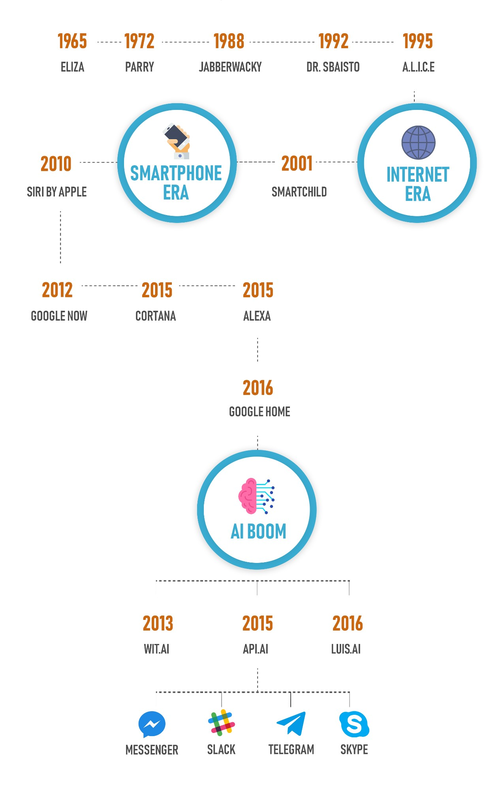

**Figure 1: history of chatbots throughout 1965 to 2016**

This healthcare chatbot system will help hospitals to provide healthcare support online 24*7. It also gives the basic medications to the customers and if needed it suggests the customers visit the doctors in case of emergency

# ❖ Processing Of Chatbot

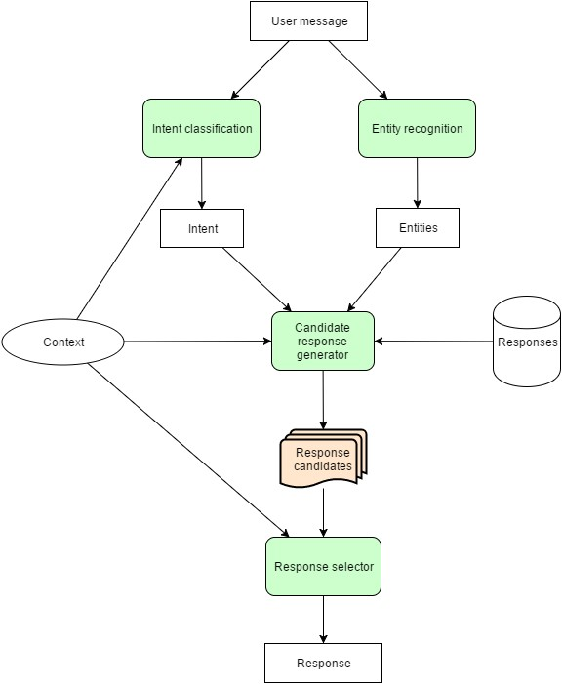

**Figure 2: This is the architecture of chatbot (**Intents: Intents refer to goals of customer

Entities: Entities used to add values to search

Candidate response generator generates response for user to give to respected questions

Context refers to collaborative act

Response refers to chatbot replies)

First, it tries to get input from the user then process input and return the value that generated the highest confidence value from the logic adapters then return the response for the input.

➢ **The general process of building a chatbot is :**

* Preparing the dependencies
* Import classes
* Create and train the chatbot
* Communicate with python chatbot
* Training the python chatbot with a corpus of data

# ❖Ease of use

* Faithful assistant in the pocket:

Chatbots integrated with relevant mobile apps help the sick yet busy and the on-the-go patient to schedule appointments, issue reminders, manage test results, information on dietary choices and even initiate a medication refill. In the role of a virtual nurse, these chatbots are trained using customized questions and their answers regularly handled by physicians.

* Effective:

Experts believe that through extensive data analysis machines will soon predict diseases better than humans.

* First level primary care and Emergency first aid:

The critical situation when you require last-minute help, may not be improved by waiting for a message response from a busy physician or by planning an emergency visit to a clinic located a long way away. A tried and tested chatbot service, specially trained in dealing solely with such emergencies, is often heaven-sent answer at such junctures.

# ❖Some Common Mistakes

Most common problems faced by current generation chatbots are:

## Making chatbot Affordable

* Especially when we are trying to sell to the board of Directors, Regardless of Business benefits of integration of chatbot into any business model, its matter of who pays it
* We might consider building a chatbot ourself using free software. This Not only will result in an inferior product, the hidden costs will soon pile up, too.

**Making chatbot secure**

o A chatbot should have robust security from day one. Users expect certain security protocols such as HTTPS and HTTP metadata attached to any internet channel that makes use of their personal data. Anything which is not a secure site and users will flat-out refuse to use chatbot. o Need to ensure that security measures are in place, such as Endto-End Encryption, Two Factor Authentication, Biometric Authentication, and Authentication Timeouts. Conduct testing of Chatbot by running Penetration Tests and API Security Tests.

o Being up to date with the latest developments in chatbot cybersecurity applications. However, this type of force requires specialist expertise.

## Getting people to like chatbot

* We need a chatbot that moves past the ‘gimmick’ tag many tech devices suffer from and actually offers users something they’ll want to interact with – be it voice-activated or textbased. It does not necessarily have to be ‘almost human’ – users would rather interact with a chatbot that delivers highquality, relevant responses than one that’s overly friendly.
* The five key elements to getting people to use a bot:
  1. It needs to be useful
  2. It needs to be relatable
  3. It needs to be accurate
  4. It needs to be trustworthy
  5. It needs to be likeable

**Choosing between text-based chatbots and Voice activated chatbots**

o The fact that we can choose between two different types of chatbots gives us a bargaining chip when we’re trying to convince other parties within organisation that a chatbot is a smart, workable channel through which we can connect with our customers. While customers might not be ready to take the leap and develop a VA chatbot just yet, reluctant parties may be more inclined to entertain the idea of a text-based chatbot instead, especially if we have already have a strong digital footprint.

* Voice Activated chatbots…
  + Are more suitable for static use – if our user base needs a ‘go-to’ point or wants to integrate other IoT

(Internet of Things) technology such as a home hub

* + Having a greater ‘personality’ quota and are crossgenerational in their appeal
  + And are more expensive to develop and maintain o Text-based chatbots…
  + These are ideal for mobile devices and informationspecific responses such as online banking or financial information
  + Utilizing devices that your users are already familiar with (smartphones and tablets)
  + And these are cheaper to develop and maintain

## Making sure chatbot provides real value to users

o There is no point delivering an engaging, technologically advanced chatbot – if it doesn’t actually do anything! Chatbot should have a USP to make it attractive to users, and top of the list is a chatbot that makes their lives easier in some way. Which could be supplying them with instant access to personal data, giving them useful information that enriches their experience (or even makes their day better) or helping them in their work.

* Think carefully about who will be using chatbot, and what they want
* Does it have an USP?
* How far is it better than other chatbots?
* Decide if we need a chatbot with specific features tailor-made to our target audience.

## Getting to know our chatbot audience

The technical challenges of developing chatbot can be easily overcome by experienced designers, but we still need to ensure that our chatbot has someone to talk to once it’s out there. To do this, we have to understand our audience.

* Try to learn how Chatbots are deployed in your particular industry.
* Talk to Chatbot developers about whether they have any case studies that would provide insight into how a particular customer-base has reacted to Chatbot deployment in the past. •Carry out some demographic analytics of current audience (especially if they are using other digital channels to interact with your business or organization) through a quick questionnaire, online survey, or email marketing campaign.

## ❖ Building the bot (the 4 steps to a better user experience)

The technical aspects of building a chatbot will depend on what type of chatbot we want to develop. A purely text-based bot will be much easier to develop than a voice-activated version most of the times as beginners.

For any industry, there has to be a set process that the chatbot goes through, so it’s important to develop an ‘intelligent’ platform that:

1. Finds out the goal of the user by asking a set of questions and responding to the answers in a coherent manner
2. Collects relevant information from user.
3. Processes the data and uses its analysis to respond to the goal of user.
4. Stores information in a database so that if the same query arises again, it can use the information to form a more accurate response which is generally known as machine learning.

❖**Tabular design of disease record:**

|  |
| --- |
| NAME OF THE DISEASE/ILLNESS |
| Tags: |
| Threshold: |
| Symptoms: |
| Score= Value Symptom Check Question Recommended Medication  • Med 1  • Med 2  • etc.  Recommended Remedy  • Precaution  • Remedy  • etc |

For example:

|  |
| --- |
| MIGRAINE |
| TAGS: Headache, Head pain, pain, eye pain, eye |
| Threshold |
| Symptoms |
| Score= 2  Do you experience pain in your eyes? Recommended Medication  • ibuprofen  • Aspirin Recommended Remedy  • Stay away from light. Close your eyes and relax.  • Wash your eyes with cold water |
| Score= 1  Do you feel like vomiting? Recommended Medication  • ibuprofen  • Aspirin Recommended Remedy  • Drink warm water.  • Stay in a cold place. |

❖**Using Dialogflow API**

There are various platforms available to create a chatbot such as msg.ai, wit.ai, Dialog flow, Microsoft Language Understanding Intelligent Service (LUIS) etc. Dialog flow was chosen for this project because, the platform is very intuitive, the ease of creation of the chatbot was better when compared to other platforms, provides support for large set of languages and it provides integrations to various third-party apps. But most of the platforms follow the same concepts and terminologies**.**

A dialog system or conversational agent (CA) is a computer system intended to converse with a human, with a coherent structure. Chatbots are typically used in dialog systems for various practical purposes and use sophisticated NLP systems. The criterion of intelligence depends on the ability of a computer program to impersonate a human in a real-time written conversation with a human judge, sufficiently well that the judge is unable to distinguish reliably between the program and a real human.

Dialogflow (formerly api.ai) is Google-owned developer of humancomputer interaction technologies based on natural language conversations. Dialogflow helps us build natural and rich conversational experiences that gives users new ways to interact with the product by building engaging voice and textbased conversational interfaces powered by AI. Dialogflow incorporates Google’s machine learning expertise and products such as Google Cloud Speech-to-Text and is backed by Google Cloud Platform which can easily scale millions of users. Using years of domain knowledge and NLU, Dialogflow analyzes and understands the user’s intent and responds in the most useful way.

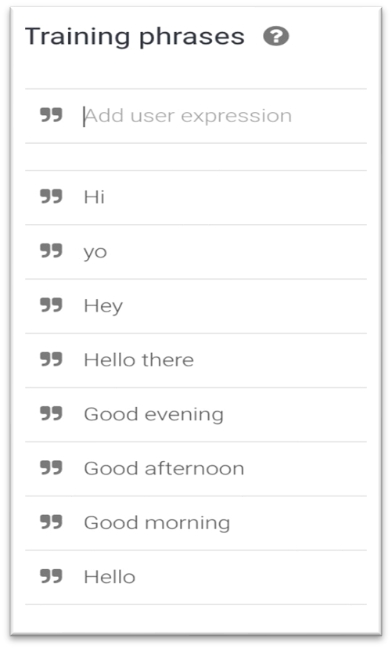The process a Dialogflow follows from invocation to fulfillment is similar to someone answering a question, with some liberties taken of course. In order to start a conversation with an agent, the user needs to invoke the agent. A user does this by asking to speak with the agent in a manner specified by the agent’s developer.

But the agent is trained using NLP and machine learning techniques such as word embedding, user data, lexical synonyms, bagof-words, synonym detection, regular expressions, tokenization, tags, supervised learning etc. and hence was able to detect what the user said.

❖ **Decision Tree of Chatbot:**

Agents work based on decision trees and at each step of the conversation flow, it can have multiple paths to proceed and determines the best path based on the previous outcome and input.

We made decision tree by using the data of symptoms and its illness and then using the follow-up feature of intent. The picture below is the small snip of how we made it:

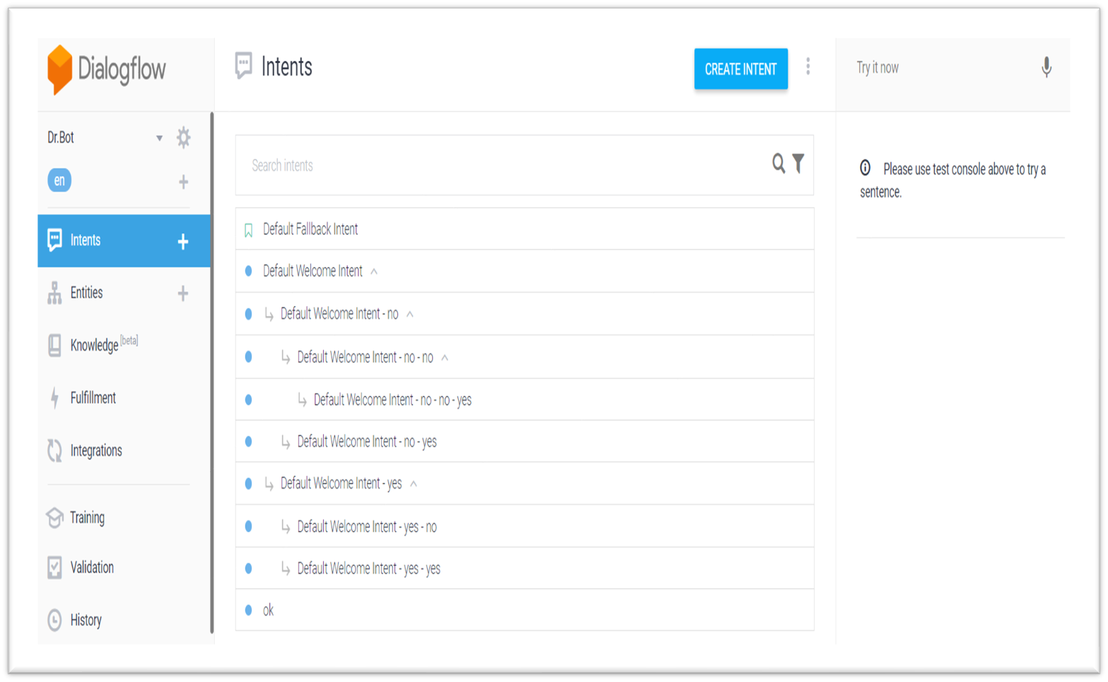

**Figure 3: Screenshot of our bot flowchart, described in below page detailed**

Below figure shows a small part of the decisions taken by our bot. This figure covers a portion of the illness such as common cold, diabetes, gastric problem, COVID-19 and interested activities.

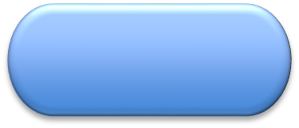

Feeling Fatigue?



(

If ,NO)

have diarehia?



(

If YES)

Major Symptoms of Gastric

problems detected



if NO )

(

watering eyes?



if YES)

(

Major Symptoms of allergy

detected



(

if NO)

Major Symptoms of COVID detected



(

if YES)

Cough and fever?



(

if YES)

Major Symptoms of Common

Cold



(

if NO)

Major Symptoms of Diabetes

**Figure 4: decision tree diagram for having fatigue**

* **Developing the chatbot**

Building chatbots that integrate within a digital system specially if chatbot is an integrated system that uses both online portals and IVR telephony is a task that requires a considerable amount of expertise.

By far the best option available is to work with a specialist to create a bespoke system specially adapted to your business. While there are platforms that allows us to build generic bots, they lack the nuance of tailored designs, are unlikely to provide our customers with a satisfactory experience and will be difficult to integrate into our wider channel shift strategy.

* **Normalizing the tech within existing digital channels**

Integrating chatbots into existing digital channels should be fairly straightforward, especially if both us and our customers are already familiar with instant messaging protocol.

Networking a chatbot to other parts of our set-up is a matter of embedding links to online content, ensuring that there are no protocol conflicts between channels, and that theirs is a clear route map for users to take to the chatbot and back again.

To fully reap the benefits of our Chatbot, it helps to integrate it into an omnichannel system that makes full use of IVR, email, mobile sites, and SMS integration. This requires an comprehensive channel switch strategy that experienced customer service technology providers will help us to implement.

* + Get users to get signed up for the chatbot service by signposting them to the service via other channels
  + Get developers to bug-check thoroughly before releasing the chatbot so that there are no coding or protocol conflicts.
  + Channel shifting users towards the chatbot by using incentives such as priority responses, access to special codes that unlock exclusive deals, etc.

## ❖ Making sure the chatbot fits in with brand identity

A long-term brand identity is the biggest marketing tool. Whether we’re a business or a public-sector organisation, it’s how people recognise us. Our chatbot needs to complement our brand.

Consequently, we should look for a chatbot specialist that is willing to work closely to develop a chatbot that truly represents and respects our unique identity. Whether it’s adapting scripts to meet our specific needs and demands or providing solutions to customer inquiries that are unique to our line of work, Our chatbot partners will want to work side-by-side with our team to ensure the chatbot reflects our brand.

* If our brand identity is fun and light-hearted, Our chatbot should match that by being friendly, chatty, and personalized
* For a more business-orientated chatbot, refined, professional language is quite essential with a complete absence of emojis!
* VA chatbots – the voice we choose should be a representation of your business, which may determine whether you choose a male or female voice.

## ❖ Managing Chatbot

While most of the Chatbots are sometimes portrayed as largely selfsupporting, there needs to be some tweaking now and again to ensure satisfactory performance.

For many of the people who go down the route of building a free chatbot themselves, this is where costs begin to add up.

As everybody knows, poor service drives potential customers away and ensures that they’re unlikely to ever return. This is very significant danger with poorly designed, free chatbots.

Instead, we would like recommended partnering with a Chatbot specialist that:

* Is communicative and available 24/7, If there are issues with Chatbot maintenance or you want to make changes to the script, these need to be carried out as soon as possible.
* Provides 365 days maintenance services and guarantees the proper functioning of the bot.
* Try to offer a reporting service that feeds back useful user data to your management team.

## ❖ Coping when things go wrong

Nothing is ever perfect, but by careful management and thoughtful construction at the front end, we can minimise potential problems later on. However, if things do go wrong, we’ll need a contingency plan. Or, better yet,We need to be able to jump on the phone and get Chatbot provider working day and night on a fix.

* Ensure IT team are up to date with the programming language and protocols that chatbot uses.
* Have a robust security measures in place so that failure is not the result of a hack or virus.
* Take feedback from users on board – if your chatbot isn’t measuring up then react sooner rather than later to adapt the programming and make it more user-friendly.

### Knowing when a human needs to take over

Problem comes when successful integration of digital technologies like chatbots is the idea that people would always rather talk to a human than a machine.

This is a common misconception that for ex in a recent survey done by HubSpot, 55% of consumers said they were interested in using a chatbot to interact with a business. Still not convinced, okay what about this, Mind browser’s 2017 survey found that 95% of users believe the customer service aspect of business will ultimately be enhanced by chatbots.

However, there are always those cases where a chatbot simply cannot fully resolve a query, so always ensure that there is always a human being that can take over if necessary.

* Always make sure that there is an option for user’s to switch to a human operator.
* always include a ‘back door’ that users can access if the chatbot interaction isn’t working for them.
* Help the users feel valued by providing them with vanity codes that can enable them to bypass automated telephony systems and go straight over to a human operator.

❖ **Understanding how successful the chatbot is**

Chatbots are most popular with consumers, with 48% of users in a HubSpot poll saying they would rather interact with a business through a chatbot than any other means of contact. But are all users having the same experience?

Analytics shall tell how many interactions the chatbot is handling, the average interaction duration and whether you’re suffering a higher-than-average drop-out rate. Most Chatbot provides built-in analytics modules and file regular usage reports for those members of your organisation that need them. Not just this but direct customer feedback is also very important, so:

* Poll user and ask them directly how they’re finding their chatbot experience.
* Always try to take on board comments on how the chatbot could be improved, and, just as importantly, what you’re doing right.
* Compare the chatbot channel to other digital contact points to see if there are other, more effective routes we could integrate into the chatbot protocol.

Now chatbot askes if person is having any fever or cough

This is the screenshot of the bot we made   
when we start the conversation first our bot will introduce itself

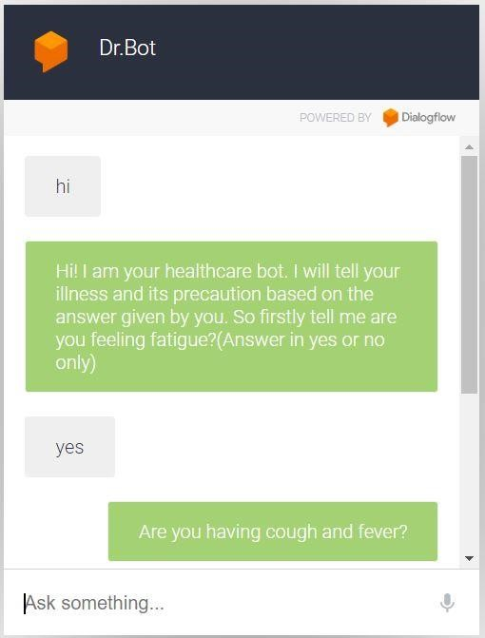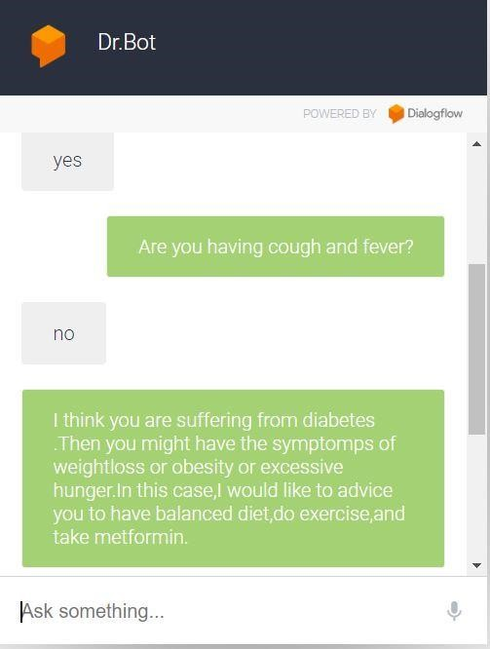

**Figure 5: screenshots of our bot**

# ❖ Future-proofing of chatbot

Technology moves at a frighteningly fast pace, so I guess it’s important to avoid the perils of obsolescence by future-proofing chatbot though integrated Artificial intelligence represents the next generation of communication, it might not be the chatbot that hyperevolves, but the hardware used by customers. If incorporated machine learning protocols into chatbot then it should be able to keep pace with external technology advances.

We should also work to update our tech and keep us abreast of developments. However, we can also make sure:

•We shall employ the very latest generation of Natural

## Language Processing software and update it regularly

* We have to plan ahead for new platforms such as next-gen hardware
* Keep a close watch on chatbot development and if our chatbot is on a supported platform, ensure the provider issues regular updates.

# ❖ Word order similarity among sentence’s:

# The order of words is important too because change in order of words would result in wrong outputs, for example : 🡪 “chicken can’t swim but dogs can” lets change its order: “dogs cant swim but chicken can” thus the meaning of both sentences is completely different 🡪 Therefore we must form word order vectors for both sentences, namely r1 and r2. For the very first sentence, this is achieved by doing the following for each word w in the joint word set:

# 1. If the first sentence contains v, we fill the entry in “r1” with the corresponding index of v in the first sentence.

# 2. If the first sentence does not contain v, we find the word from the first sentence, which is most similar to v. This word is denoted as ~v. If the similarity of those is greater than the pre-set threshold, we fill the first sentence’s vector entry with the corresponding index of ~v in the first sentence. If the similarity between them is not greater than the threshold, we fill the vector’s entry with 0.

* The Threshold is very important because we are calculating the word similarity of different words and therefore the similarity measures could be very low. Since that mean “s” the words are not similar, we do not want to introduce such noise into our calculation. When we increase the threshold, we might potentially introduce more noise to our calculations, which is not desirable. We’ll repeat the process for both sentences, so we obtain word order vectors for both sentences. The final value of/for the word order similarity measure is evaluated using the following formula:

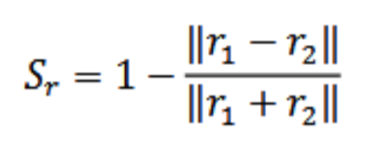

* Words order similarity is measured among two sentences is calculated as a normalized differentiation of word order. The measure is very sensitive to the distance between two words of the word pair. If the distance increases then the measure decreases.

**H=Σ (Score) / Threshold Value**

H = It’s the decision parameter which is used to check if the threshold level was hit.

Σ (Score) = It’s the total score of all the symptoms that the user claims to experience.

Threshold Value = It’s the upper limit value until which the Chatbot can handle.

Condition for triggering= if H >= 1 the chatbot connects the user to the doctor

* **Future-work which can be done on our chatbot:**

Along the time and more deep knowledge, we can add more features to our chatbot like:

1)Adding more training data for more accurate prediction.

2)Adding one more function of booking appointments to the doctors according to the patient’s location

3)Can provide this chatbot a more segregated and user-friendly interface.

4)For making it personal healthcare doctor, we can add a function of keeping the record of patient’s data so that chatbot don’t have to ask same questions everytime patient visits the platform.

5) Taking feedback from users on board – if your chatbot isn’t measuring up then react sooner rather than later to adapt the programming and make it more user-friendly.

* **CONCLUSION:**

The review concludes that the usage of Chatbot is user friendly. So by using Chatbot it does not matter how far a person is, the only thing that is required are a simple desktop, tablet and smart mobile etc. The smartness and intelligence of the chatbot can be increased by conducting more study and increasing the database so that Chabot could answer all type of question about every type of disease.

* **REFRENCES:**

[1] Javier. (2015). Building the Chatbot: analysis & limitations of modern platforms. Retrieved from tryo labs: https://tryolabs.com/blog/2017/01/25/building-a-chatbot-analysis--limitations-of-modernplatforms/

[2 Sameera A. Abdul-Kader, D. J. (2015). Survey’s on Chatbot Design Techniques in Speech Conversation Systems. International Journal of Advanced Computer Science and Applications.

[3] https://wit.ai/ <https://www.luis.ai/home>

[4] Chatbots will serve as health assistants - http://medicalfuturist.com/chatbots-health-assistants/

[5] https://www.techemergence.com/chatbots-for-healthcare-comparison/

[6] Akshay Aravind, Laxmi Priya Neha Majesty, Sanjana Rajagopal, Vinutha Karanth: Natural Language Processing IST 664 / CIS 668

[7] Build natural and rich conversational experiences. (n.d.). Retrieved from Google DialogFlow: <https://dialogflow.com/>

[8]Woudenberg, A. v. (2014). Chatbots and Dialogue Systems: A Hybrid Approach. Open University of the Netherlands

[9] <https://en.wikipedia.org/wiki/Chatbot>

[10] [Margaret Rouse](https://www.techtarget.com/contributor/Margaret-Rouse) techtarget.com <https://searchdomino.techtarget.com/definition/IM-bot>

[11] Google <https://en.wikipedia.org/wiki/Dialogflow>